**Advancing Liver Tumor Segmentation: Integrating UNet Architecture and Computed Tomography for Improved Diagnosis**

Harish Nandhan S1*, Remoon Zean J2, Harshini J3, Mahi A R4, Gopinath K5

harishnandhan02@gmail.com*, remoonzeanj@gmail.com2, harshinijayakumar2908@gmail.com3, armahi2003@gmail.com4, Gopinath.k@rajalakshmi.edu.in5

1,2,3,4*Department* of Artificial Intelligence and Machine Learning, Rajalakshmi Engineering College, Chennai, India

5*Assistant Professor(SG),Department* of Artificial Intelligence and Machine Learning, Rajalakshmi Engineering College, Chennai, India

*Corresponding author e-mail address: harishnandhan02@gmail.com

**Abstract—The liver facilitates in keeping healthy blood sugar levels, eliminating toxins from blood supply to the body, as well as regulating blood coagulation. Additionally, it will regulate the blood's chemical composition and release bile. Since the liver contains a variety of cell types, a variety of distinct tumor types can grow there. These aberrant growths may develop into malignant (cancerous) or benign (non-cancerous) cancers. The three most common malignant liver tumors are hepatocellular carcinoma, sarcoma, and hepatoblastoma. These illnesses cause weight loss, abdominal swelling, nauseousness, and vomiting. The final stage may also result in death. To eliminate and treat liver tumors as quickly as possible, earlier detection is required. The liver tumor is found using a medical imaging technique called Computed Tomography (CT), which is then sent to a convolution neural network architecture for biological image segmentation (UNET) that will precisely segment the liver's malignant cancer cells. In addition to the standard approach, a dropout regularization has been employed here to lessen the number of filters and prevent model bias. The dataset used to train the model was taken from the LiTS - Liver Tumor Segmentation Challenge (LiTS17) dataset, which contains roughly 130 CT scans for segmenting the liver and tumor lesions. The output will have a portion of the image that has been highlighted to show the presence of cancer cells, and the suggested methodology aids in the quick retrieval of tumor identification.**

***Keywords—Liver tumor - Hepatocellular Carcinoma - Computed tomography (CT) - Convolution Neural Network - UNet - Tumor segmentation***

# Introduction

The human body's liver is located in the upper right quadrant of the abdominal cavity. It is a crucial organ because it receives two blood supplies, three-fourths of which come from the portal vein and the other half from the hepatic artery. The primary job of the liver is to make bile, a substance necessary for the small intestine to digest and absorb lipids.

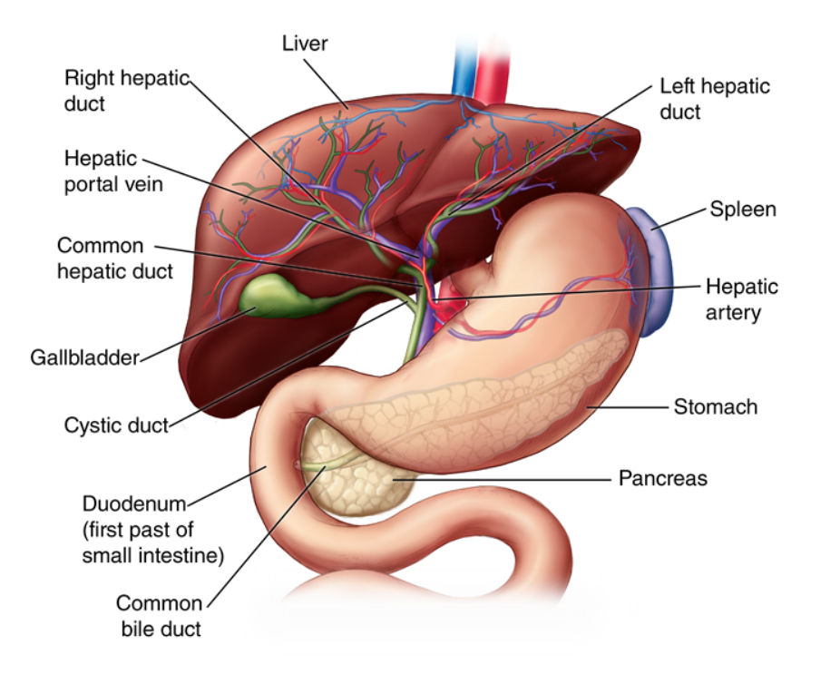

Fig.1. The Liver

The liver is a 3-pound organ that is dark reddish brown in color. The hepatic portal vein transports nutrient-rich blood from the digestive system to the liver, whereas the hepatic artery is in charge of supplying the liver with oxygenated blood. Without the actions of the liver, other bodily tissues would be at risk of degenerating or perhaps dying from a lack of nutrients and energy. Different types of aberrant liver cell development might be benign or cancerous. Benign liver tumors come in a variety of forms, including focal nodular hyperplasia, hepatic adenoma, and hemangioma. A malignant tumor spreads cancerous cells throughout the body. Either primary or secondary are possible. A cancerous tumor that starts in the liver is referred to as a malignant primary hepatic tumor. A malignant secondary liver tumor originates in another area of the body and spreads to the liver by metastasis. The most common malignant liver tumor is hepatocellular carcinoma. Cholangiocarcinoma, Sarcoma, Mixed tumors, and Hepatoblastoma are a few other uncommon malignant liver tumor types.

Early on, symptoms are typically absent; but, once they do appear, they can include: upper right abdominal pain or discomfort, loss of appetite, weight loss, fever, excessive sweating, feeling lousy, nausea, and vomiting. Additionally, it might cause skin itchiness, jaundice, and anemia. The patient's medical history and a physical examination are required for the diagnosis.

CT scans, MRIs, and ultrasounds are the principal diagnostic tools for detecting liver tumors. A comprehensive image of our body is produced utilizing a form of X-ray known as a Computed Tomography (CT) scan. It can be used to find out if the body has cancerous cells. UNet, a deep learning-based Convolution neural network for biomedical image segmentation, is used to detect the presence of cancer cells in a very short amount of time because manual detection of malignant cancer cells takes more time to diagnose and cure.

# Literature survey

In [2] For the purpose of detecting liver cancer in CT scans, they mainly used modified fuzzy clustering and decision tree classifiers.Tumour and non-tumor zones are successfully separated using their upgraded fuzzy clustering technique. The decision tree classifier, which labels segmented regions as malignant or non-cancerous based on extracted features, enables automated liver cancer diagnosis in CT scans.

In [5] Sharma used Various ML approaches for the early detection of liver cancer for preventative healthcare utilizing image processing. Deep learning algorithms like convolutional neural networks (CNNs), support vector machines (SVMs), and decision trees are some of the often employed methods. With the use of these algorithms, medical images were accurately analyzed and liver cancer can be effectively predicted at an early stage.

In [10] They examined cascaded deep residual networks to automatically detect liver lesions. The model successfully captures the hierarchical information and iteratively improves the lesion detection outcomes by using a cascaded design. Deep residual networks improve feature extraction and improve liver lesions representation.

In [1][3] They concentrated on noise reduction and intensity normalization, initializing contours close to the tumor, and iterative contour deformation driven by an energy function that balances boundary attraction and contour smoothness. The proposed a technique for extracting and classifying liver abnormalities using a combination of neutrosophic theory and an SVM classifier.The SVM classifier successfully classifies liver abnormalities, while the neutrosophic theory permits addressing uncertainty in medical imaging. The suggested method presents a potentially effective technique for the precise extraction and classification of liver anomalies, supporting more accurate diagnostic and therapy choices.

In [4] the mechanism concentrates on significant visual portions.This method provides a reliable and efficient way for precisely segmenting liver tumors in CT volumes, assisting with clinical diagnosis and treatment formulation. Convolutional neural networks (CNNs) and perhaps other deep learning architectures are among the machine learning (ML) techniques utilized in the application for segmenting liver tumors in CT volumes with attention mechanism and hybrid connections. These algorithms take advantage of deep learning to analyze CT volumes and accurately segment liver tumors, enhancing medical imaging diagnostic skills.

In [6] Z. Bai, explored for segmenting liver tumors, is based on fractal residual networks and multi-scale candidate generation. To capture various tumor sizes and forms, multi-scale candidate generation creates tumor candidates at various scales. In order to precisely segment liver tumors in medical pictures, the fractal residual network is used to efficiently extract tumor features and optimize the segmentation findings.They used deep learning algorithms like convolutional neural networks (CNNs) and other machine learning techniques. The used machine learning approaches allow for the automatic and accurate segmentation of liver tumors in medical images.

In [9] Lei Xu, proposed liver segmentation approach makes use of a new signed pressure force function in addition to region developing and level set active contour models. The algorithm K-means clustering can be used to group pixels with similar properties and find initial seed points inside the liver region during the region-growing stage. CNNs can be used to extract valuable features from the liver image data using the level set active contour model. The contour evolution is then guided by these features, which also increase segmentation precision. SVMs can be used to optimize the level set active contour model's parameters and weights. They can help in the contour evolution process to achieve a better balance between regularization and data fitting. Genetic Algorithm (GA) can be used to refine the new signed pressure force function's parameters. The novel signed pressure force function, created using cutting-edge methods, controls the evolution of the contour by utilizing the forces pressing on it to increase segmentation accuracy. This comprehensive strategy offers a reliable and efficient method for liver segmentation in medical pictures, enhancing diagnosis and treatment planning.

In [7] Dirk Smeets proposed an integrating supervised fuzzy pixel classification with a spiral-scanning technique, the project's main goal is to semi-automatically partition liver tumor level sets. The tumor boundaries are effectively captured using the spiral-scanning technique, and the precise separation of tumor pixels from healthy pixels is made possible with the help of supervised fuzzy pixel classification. In order to segment liver tumors in medical imaging and enable accurate analysis and diagnosis, a combination technique is offered.

Nasim Nasiri [8] analyzed on the basis of the knowledge-based restrictions, realistic tumor segmentation masks are produced using generative adversarial networks (GANs). The discriminator network assesses the realism of the segmentation masks created by the generator network. Utilizing variational autoencoders (VAEs), which produce realistic tumor segmentation masks while adhering to knowledge-based restrictions, it is possible to learn a latent representation of the tumor pictures. The VAEs' encoder-decoder architecture enables efficient tumor segmentation learning and creation.The knowledge-based constraints are incorporated as additional input or conditioning variables using conditional generative models, such as Conditional Variational Autoencoders (CVAEs) or Conditional GANs (cGANs). Both the input images and the knowledge-based limitations are taken into account as these models learn to produce tumor segmentations.

In [13] Dr. S. Vijayarani examined and used its capacity to categorize data based on support vectors. The programme builds a predictive model for the classification of liver diseases by learning patterns from the data.Second, the Naive Bayes algorithm is used, which computes the probability for each class while assuming independence across features. The individuals are then divided into several groups of liver diseases using these probabilities. Metrics including accuracy, precision, recall, and F1-score are used to assess the effectiveness of both methods. Cross-validation methods are used to make sure the models are reliable.

# Methodology

## Data Collection

The study's initial step is data collecting, which is done through the LiTS17 (Liver Tumor Segmentation Challenge 2017). The segmentations and data are supplied by numerous clinical locations globally. There are 130 CT scans in the training data set and 70 in the test data set. One can obtain these scans as NIfTI files (.nii.gz). Each image in this dataset was manually segmented and validated by skilled neuroradiologists. The.nii file reading library for Python is called Nibabel.

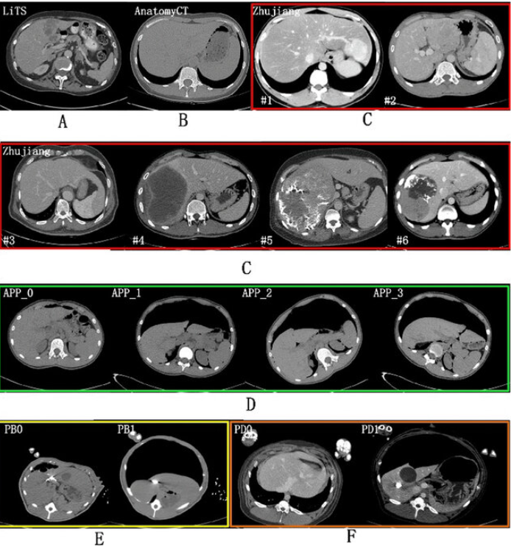

Fig.2. CT Scans of LiTS Dataset

## Data Preprocessing

For data preparation, the actions of flattening, scaling, and reformatting the data volumes are essential. masking, tagging, and storing the image as a composite volume. putting all of their favorite channels into a single volume so they can be trained later.

4 channels of information - 4 different volumes of the same region

i) Native (T1)

ii) Post - Contrast T1 weighted (T1CE)

iii) T2 - Weighted (T2)

iv) T2 Fluid Attenuated Inversion Recovery (FLAIR) volume

Images and masks needed to be stored in .npy file format.

By aligning and rotating the image, a custom data generator is utilized to randomly sample the different types of CT scans. Prior to modeling, it is used to scale the image's pixel values. During training, validation, or evaluation, it will encapsulate the picture data, return images in batches, and execute scaling operations. This offers a practical and effective method for scaling image data. To rescale pixel values from the range of 0-255 to the range 0-1 recommended for neural network models, utilize the ImageDataGenerator class. Normalization is the term used to describe scaling data to a 0–1 range.

## Segmentation using UNet

UNet Architecture was created specifically to handle biological images like MRI, CT, and FIB-SEM. It is a fully convolutional neural network with a U-shaped configuration that includes dropout, max pooling, convolution, and filter operations layers. ReLu is utilized as the activation function due to its nonlinearity when handling 3D images. By employing filters of various sizes, feature maps can be produced using very few training samples.

It is made up of a bridge, a 4 block decoder, and a 4 block encoder. The number of filters utilized will increase as the spatial dimensions are reduced by the encoder network. However, this approach keeps the filter size (feature channels) constant rather than doubling it.

By using the ReLu activation function, the bridge serves as the connecting link between the encoder and the decoder. The decoder's main goal is to create a semantic segmentation mask, and it does this by transforming the loss via a skip connection. A segmented image is sent to a 1x1 convolution with a sigmoid function as the activation function to produce the output. The outcome of this blend with Mask R-CNN is a segmented tumor image, which enhances the instance segmentation.

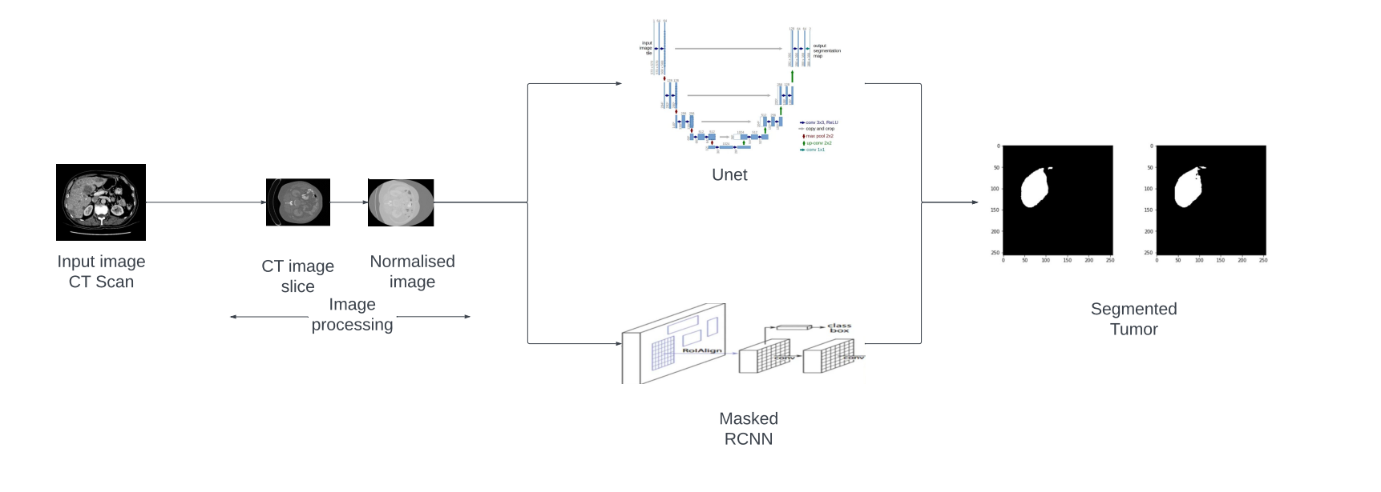

Fig.3. Architecture of the proposed model

The convolution operation in UNet is as follows:

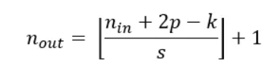

Here,

n(in) - represents the number of input features

n(out) - represents the number of output features

k - represents the convolution kernel size

p - represents the convolution padding size

s - represents the convolution stride size

Binary cross entropy is employed as the loss function and the Adam optimizer is used for optimisation of the neural network.

## Mask R-CNN

Mask Instance-based segmentation will be produced using RCNN using the Region proposal architecture. It produces a bounding box and binary mask simultaneously while working on the predict class. As the backbone architecture, any pretrained model, for instance ResNet or VGG16, will be employed. Rol generation will produce several regions of interest. Convolution feature maps are created using the region of interest. Its effectiveness, which results in a little overhead, and ease of model training are benefits of utilizing it.

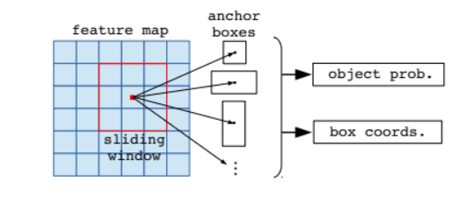

Fig.4. Region proposal Network of Mask R-CNN

# Results And Discussion

The segmented liver tumor results are displayed in the image. By maintaining the current kernel and filters and not allowing the number of filters to increase, we were able to accurately detect cancer cells early on. Our method initially normalized all of the CT scans and preprocessed them into a format that we could use. The errors are decreased by repeatedly training it through backpropagation while modifying the learning rates. Since the learning rate, which is also known as the step size, is the parameter that modifies the weights required for neural network training.

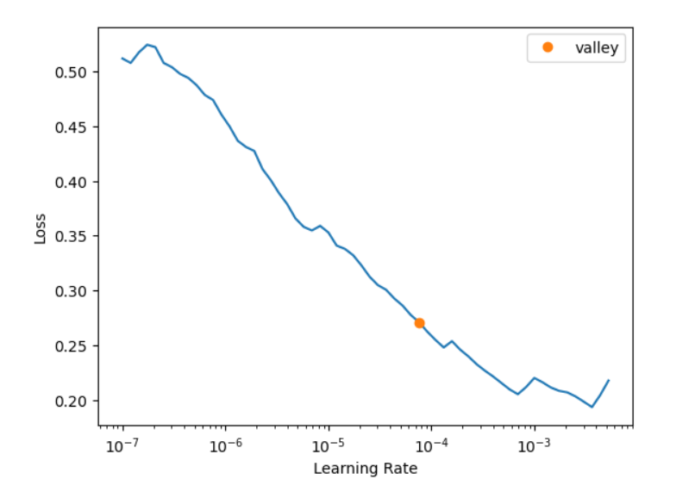

Fig.5. Learning rate or step size of the modified weights

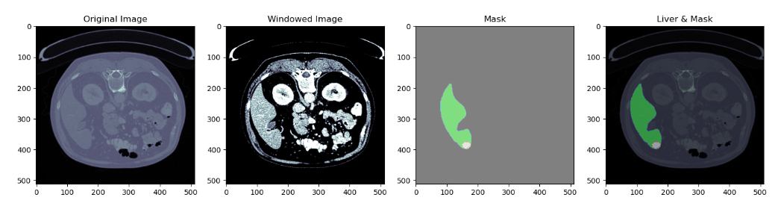

Fig.6. Results from the model's various stages

The UNet neural network architecture and ResNet backbone Mask R-CNN are combined in the suggested technique, which enhances the instance segmentation performed by the UNet Architecture. In comparison to the earlier models, it improved accuracy and did so with less computational expense. This approach can be deployed with different cloud platforms, and it can be helpful in multispecialty hospitals to detect liver tumors early, allowing the hospitals to begin treatment sooner. It can also be employed in CT scan centers so that patients can determine whether or not a liver tumor is present.

V. Conclusion

A reliable and precise approach for identifying liver tumors in medical imaging has been created and successfully put into use by the liver tumor segmentation project. The segmentation technique accomplishes accurate delineation of tumor boundaries by integrating region growth and level-set active contour models with a new signed pressure force function. The accuracy and effectiveness of the segmentation process are further increased by the incorporation of AI techniques, such as CNNs for feature extraction and optimization algorithms like UNet and ResNet backbone Mask R-CNN. The performance of liver tumor segmentation models has been significantly improved by the incorporation of cutting-edge techniques like multimodal fusion, transfer learning, and ensemble learning. To take advantage of their complementary capabilities and increase segmentation accuracy, multi-modal

fusion approaches combine data from various imaging modalities, such as CT and MRI. In order to create more reliable and effective models, transfer learning facilitates the transfer of knowledge obtained from pre-trained models that were trained on big datasets to new segmentation tasks with little to no data. To reach a consensus judgment, ensemble learning integrates predictions from various models, improving segmentation performance. Accurate segmentation can be hampered by variations in tumor appearance, size, form, and texture, as well as by the presence of artifacts and noise in medical pictures. Additionally, the lack of annotated data for deep learning model training continues to be problematic, particularly for rare or particular tumor forms.

##### References

1. T. Rajalakshmi, U. Snekhalatha, and Jisha Baby, "Segmentation of liver tumor using fast greedy snake algorithm," Biomedical Engineering: Applications, Basis and Communications, vol. 31, no. 02, pp. 1950013, 2019.doi: 10.4015/S1016237219500133
2. S. Sabut, A. Das, S.S. Panda, and P. Das, "Detection of liver cancer using modified fuzzy clustering and decision tree classifier in CT images," Pattern Recognition and Image Analysis, vol. 29, no. 2, pp. 201-211, June 2019.doi: 10.1134/S1054661819020056.
3. J. Muthuswamy, "Extraction and Classification of Liver Abnormality Based on Neutrosophic and SVM Classifier," Advances in Intelligent Systems and Computing, vol. 713, pp. 287-296, 2019, Springer, Singapore.doi: 10.1007/978-981-13-1708-8_25.
4. H. Jiang, T. Shi, Z. Bai, and L. Huang, "AHCNet: An Application of Attention Mechanism and Hybrid Connection for Liver Tumor Segmentation in CT Volumes," IEEE Access, Special Section on Deep Learning for Computer-Aided Medical Diagnosis, vol. 7, pp. 74310-74320, 2019. doi: 10.1109/ACCESS.2019.2899608.
5. M. Sharma and R. Parveen, "The Application of Image Processing in Liver Cancer Detection," International Journal of Advanced Computer Science and Applications, vol. 12, no. 10, 2021. doi: 10.14569/IJACSA.2021.0121050.
6. Z. Bai, H. Jiang, and Y.-D. Yao, "Liver Tumor Segmentation Based on Multi-Scale Candidate Generation and Fractal Residual Network," IEEE Access, vol. 7, pp. 84046-84055, 2019. doi: 10.1109/ACCESS.2019.2923218.
7. D. Smeets, D. Loeckx, B. Stijnen, B. De Dobbelaer, D. Vandermeulen, and P. Suetens, "Semi-automatic level set segmentation of liver tumors combining a spiral-scanning technique with supervised fuzzy pixel classification," Med Image Anal, vol. 14, no. 1, pp. 13-20, Feb. 2010. doi: 10.1016/j.media.2009.09.002. PMID: 19828356.
8. N. Nasiri, M. H. Foruzan, and Y.-W. Chen, "Integration of a knowledge-based constraint into generative models with applications in semi-automatic segmentation of liver tumors," Biomed. Signal Process. Control, vol. 57, pp. 101746, Mar. 2020.
9. X. Lei, Y. Zhu, Y. Zhang, and H. Yang, "Liver Segmentation Based on Region Growing and Level Set Active Contour Model with New Signed Pressure Force Function," Optik - Int. J. Light Electron Opt., vol. 202, no. 12, pp. 163705, Nov. 2019. DOI: 10.1016/j.ijleo.2019.163705.
10. L. Bi, J. Kim, A. Kumar, and D. Feng, "Automatic Liver Lesion Detection using Cascaded Deep Residual Networks," arXiv:1704.02703 [cs], 10 Apr 2017 (v1), revised 21 May 2017 (v2).
11. H. Ibrahim, M. Petrou, K. Wells, S. Doran, and Ø. Olsen, "Automatic Volumetric Liver Segmentation from MRI Data," International Journal of Computer Theory and Engineering, vol. 2, no. 2, pp. 176-179, 2010. DOI: 10.7763/IJCTE.2010.V2.136. ISSN: 1793-8201.
12. R. Rajagopal and P. Subbiah, "Computer Aided Detection of Liver Tumor using SVM Classifier," International Journal of Advanced Research in Electrical, Electronics and Instrumentation Engineering, vol. 3, issue 6, pp. 10170-10177, June 2014. ISSN (Print): 2320-3765, ISSN (Online): 2278-8875.
13. Dr. S. Vijayarani, Mr. S. Dhayanand, "Liver Disease Prediction using SVM and Naïve Bayes Algorithms," International Journal of Science, Engineering and Technology Research (IJSETR), ISSN: 2278 – 7798, Volume 4, Issue 4, PP 816-820, April 2015.